**Feedback Stations Handout**

**AP Biology**

**Negative Feedback Loop #1:** Regulation of Blood Glucose Levels

Use the diagram below to complete the steps of the feedback loop. Practice on the dry erase version first, then have your teacher check your work. Once you have your work checked, fill in the diagram below and place it in your BILL.

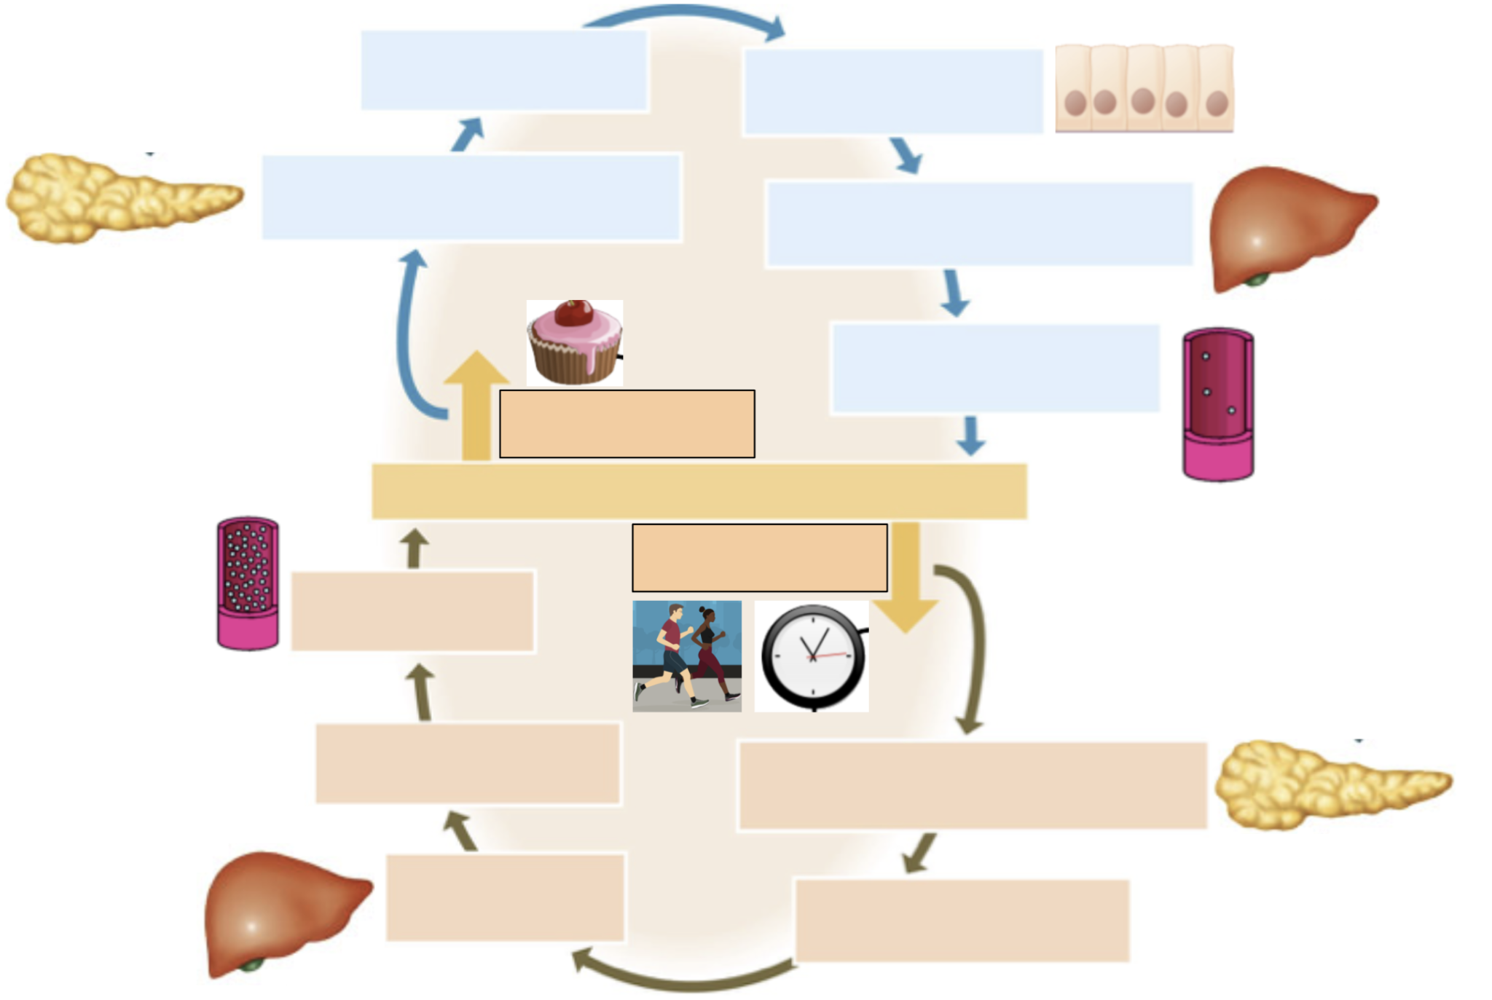

Steps:

|  |  |  |  |
| --- | --- | --- | --- |
| Insulin levels increase in the bloodstream | Liver uses excess glucose to produce glycogen, and glucose is used for metabolism | Blood glucose levels rise above normal levels (set point) | Glucagon levels in the bloodstream increase |
| Glucose is released into the bloodstream | Blood glucose level rises | Blood glucose levels drop below set point | Cells take up glucose from the blood |
| Pancreas is stimulated to secrete insulin from beta cells | Glycogen is broken down by the liver | Pancreas is stimulated to secrete glucagon from alpha cells | Blood glucose levels drop |

**Examining Graphs**

**Describe** the relationship between blood glucose levels and each of the blood sugar regulatory hormones shown in the graphs below.

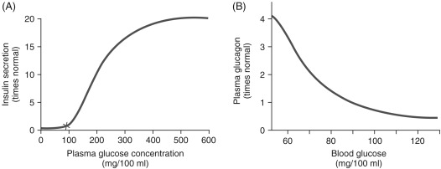

Answer the questions about the graph shown. The graph shows a student’s blood sugar levels during a typical day.

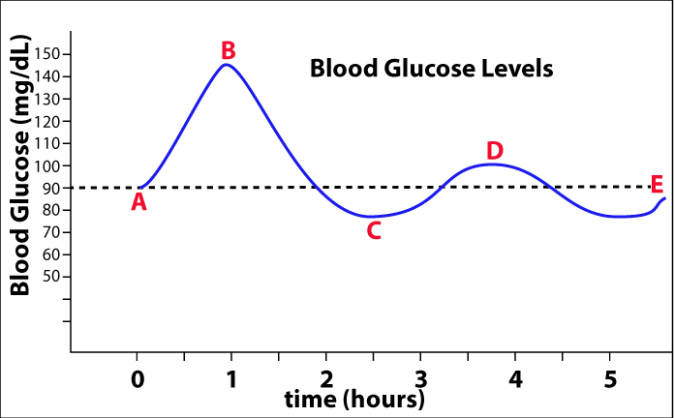

1. Which point in the graph indicates that this student has eaten a carbohydrate rich lunch?
2. Which point in the graph indicates this student’s normal blood sugar? What is this student’s normal blood sugar, according to the graph?
3. This student’s day ran a little long and they did not get to eat a snack like they usually do after school. Where on the graph will they be releasing glucagon?

**Negative Feedback Loop #2:** Thermoregulation

Use the diagram below to complete the steps of the feedback loop. Practice on the dry erase version first, then have your teacher check your work. Once you have your work checked, fill in the diagram below and place it in your BILL.

l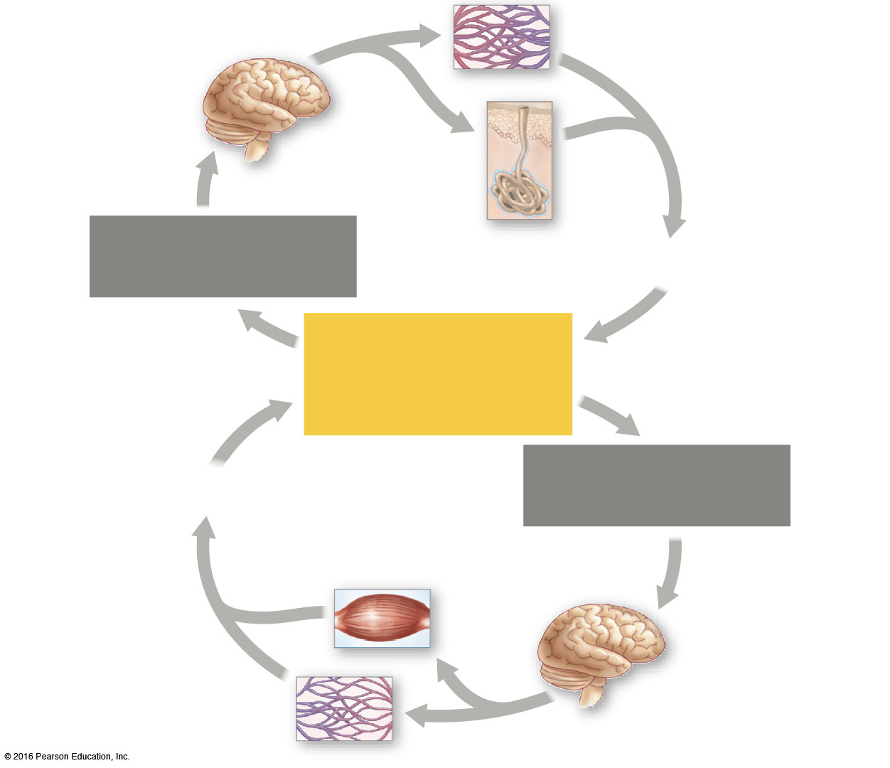

**Steps**: Some may be used more than once.

|  |  |  |  |
| --- | --- | --- | --- |
| Body temperature increases. | You shiver as muscles contract to generate heat. | Blood vessels in your skin dilate, releasing heat. | Thermostat in hypothalamus is activated to begin cooling you off. |
| Normal body temperature (36-38°C) | Body temperature decreases. | Blood vessels in skin constrict, moving heat to the body’s core. | Thermostat in hypothalamus activates warming mechanisms. |

**Temperature Regulators vs. Temperature Conformers**

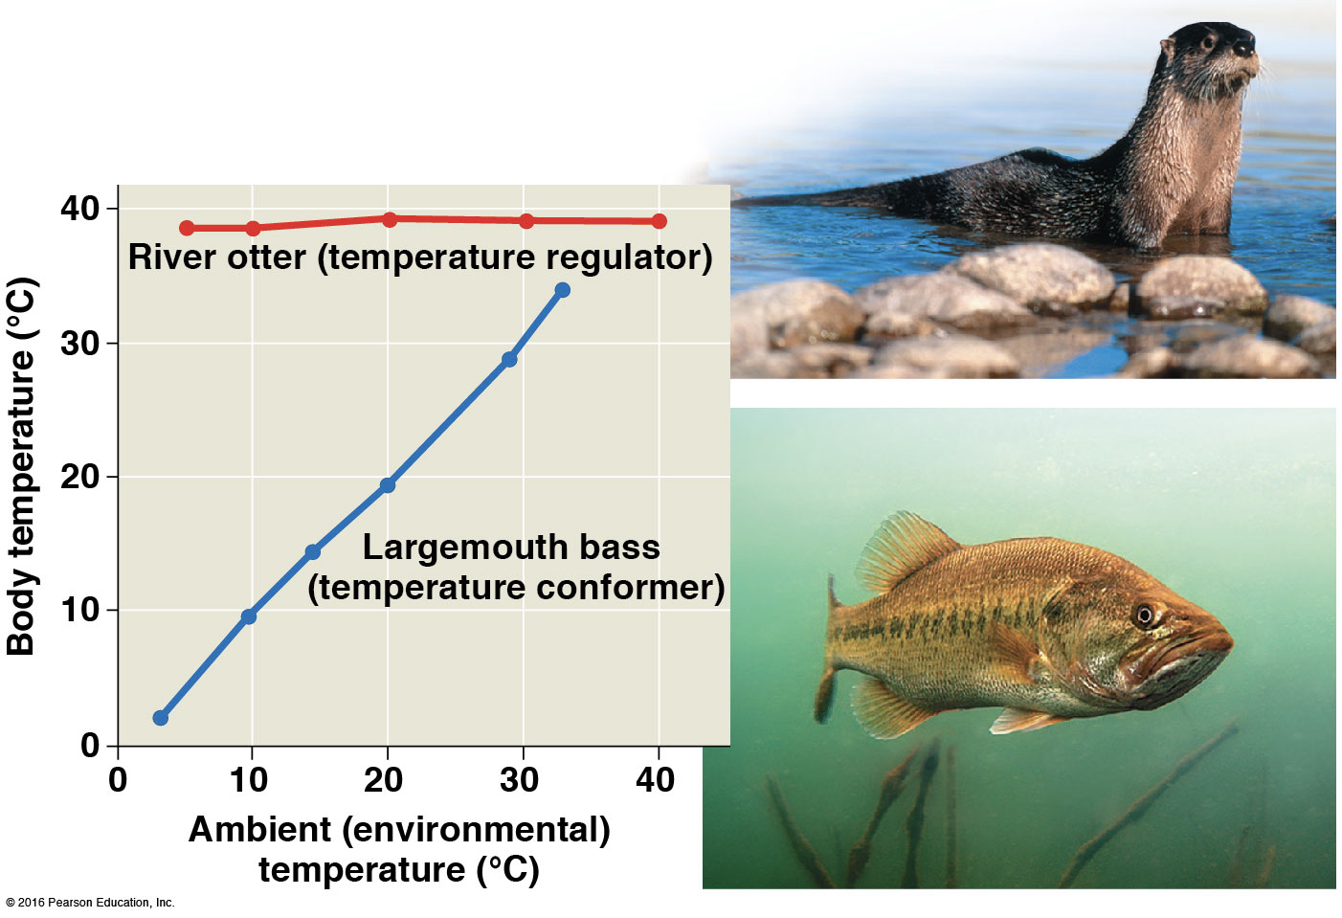

Using the data provided, explain the difference between a temperature regulator and a temperature conformer.

**Osmoregulation in Marine Fishes vs. Freshwater Fishes**

|  |  |
| --- | --- |
|  | USING WHAT YOU HAVE LEARNED ABOUT OSMOLARITY IN UNIT 2...  Explain why a marine (saltwater) fish will excrete salt from its gills and in its urine.  Explain why a freshwater fish will excrete large amounts of dilute urine from its kidneys. |

**Positive Feedback Loop #1:** Fruit Ripening

Use the diagram below to complete the steps of the feedback loop. Practice on the dry erase version first, then have your teacher check your work. Once you have your work checked, fill in the diagram below and place it in your BILL.

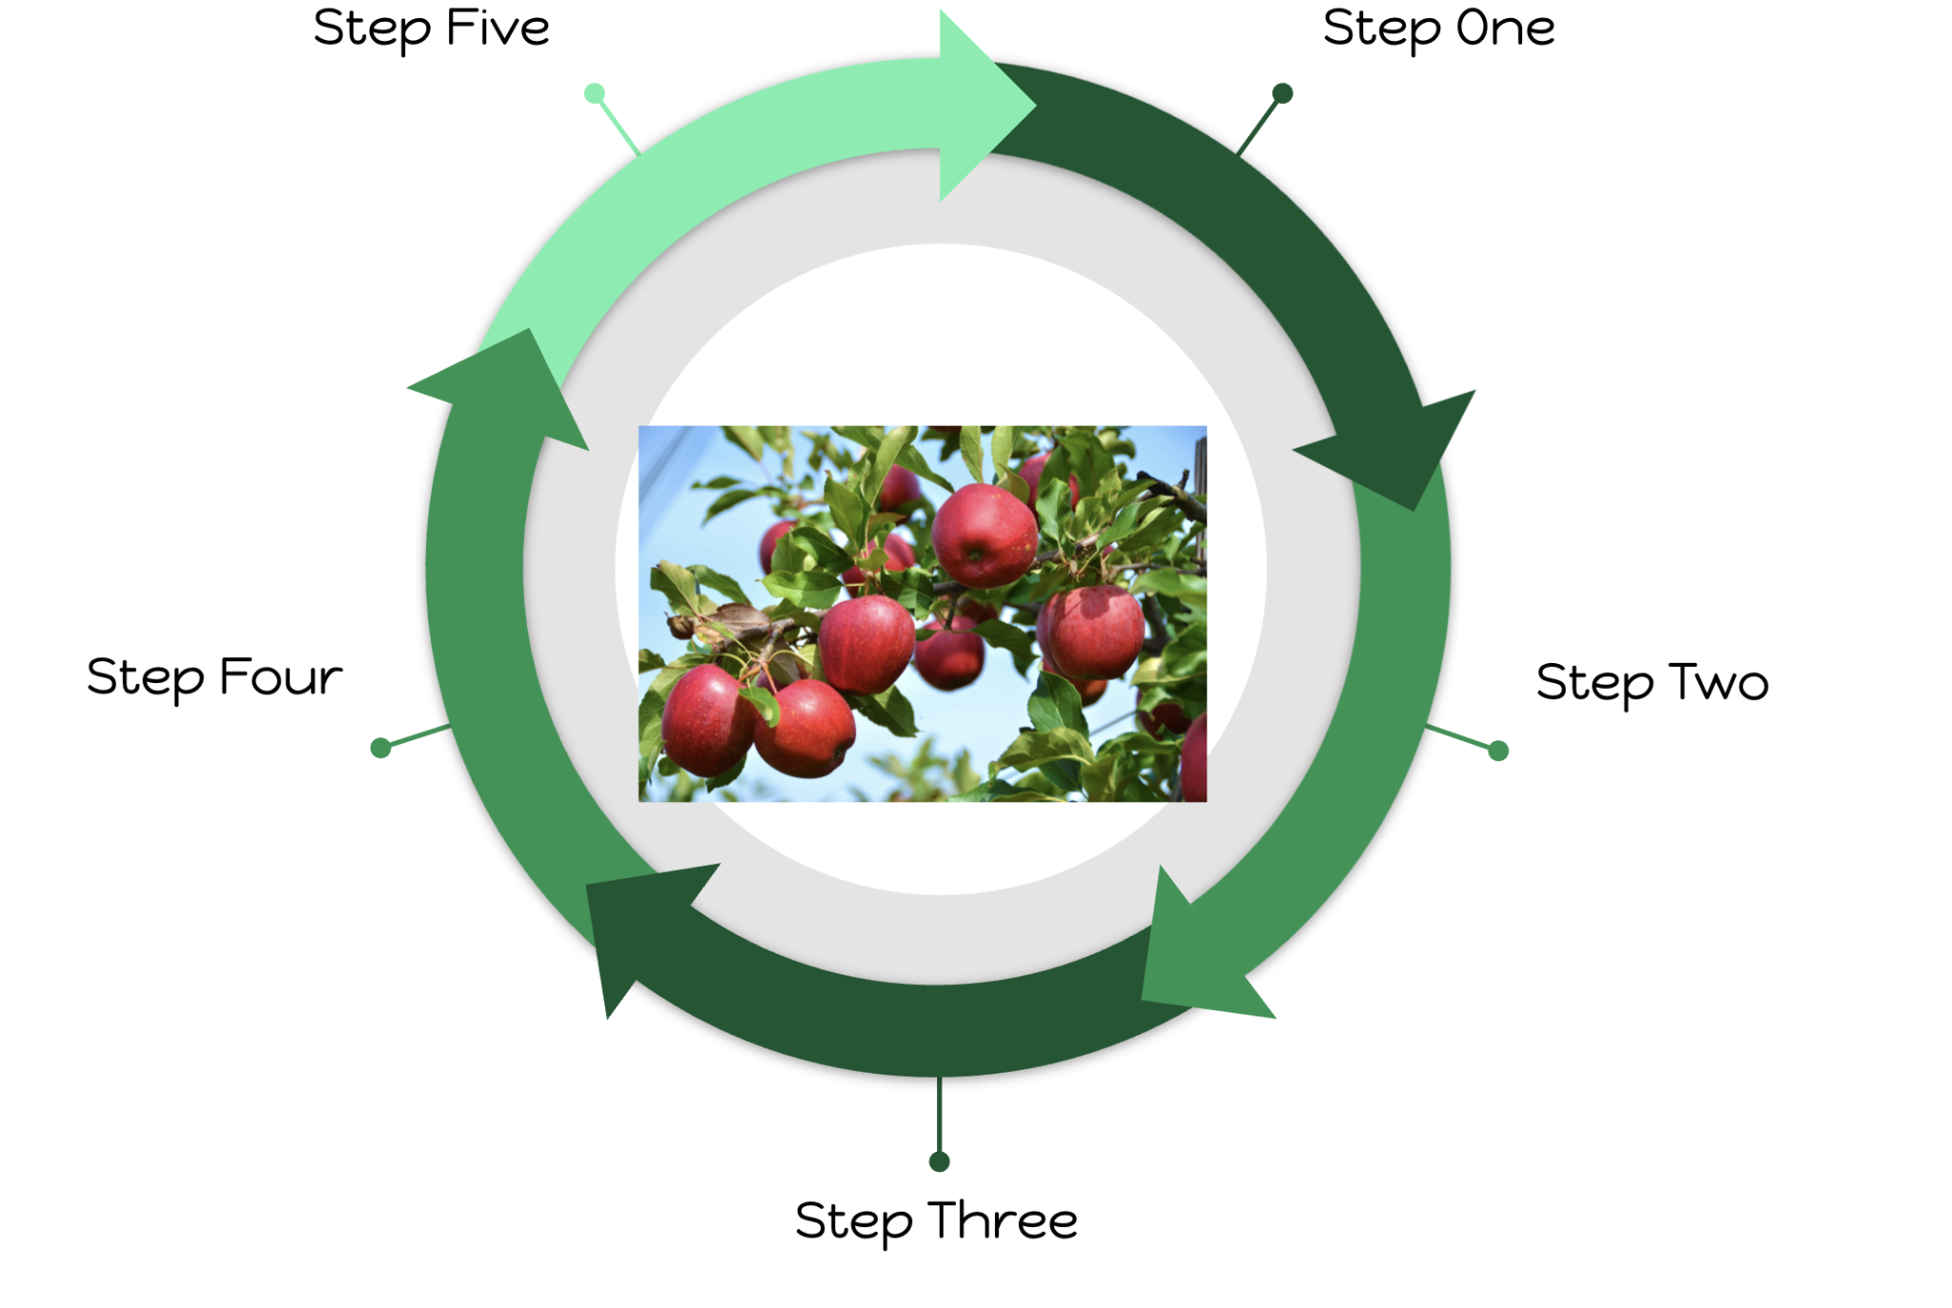

**Steps**

|  |  |  |  |
| --- | --- | --- | --- |
| More fruit ripens. | Ethylene gas produced in one fruit. | Nearby fruit detect the release of ethylene gas. | Nearby fruit begin to ripen and release ethylene gas. |
| Ethylene gas detected by nearby fruits. |  |  |  |

What does it mean for a fruit to ripen? Describe what happens when a fruit becomes ripe.

Why is it important for a fruit to ripen? What would happen if a fruit’s ethylene receptors were mutated?

Signal transduction in Fruit Ripening

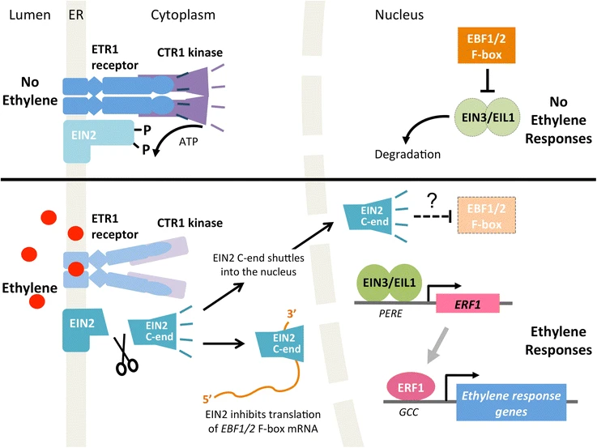

What is the role of the CTR1 kinase in the model above?

What role does ATP play in the signaling pathway above?

What is the relationship between EBF1/2 F-box and EIN3/EIL1?

**Positive Feedback Loop #2:** Childbirth

Use the diagram below to complete the steps of the feedback loop. Practice on the dry erase version first, then have your teacher check your work. Once you have your work checked, fill in the diagram below and place it in your BILL.

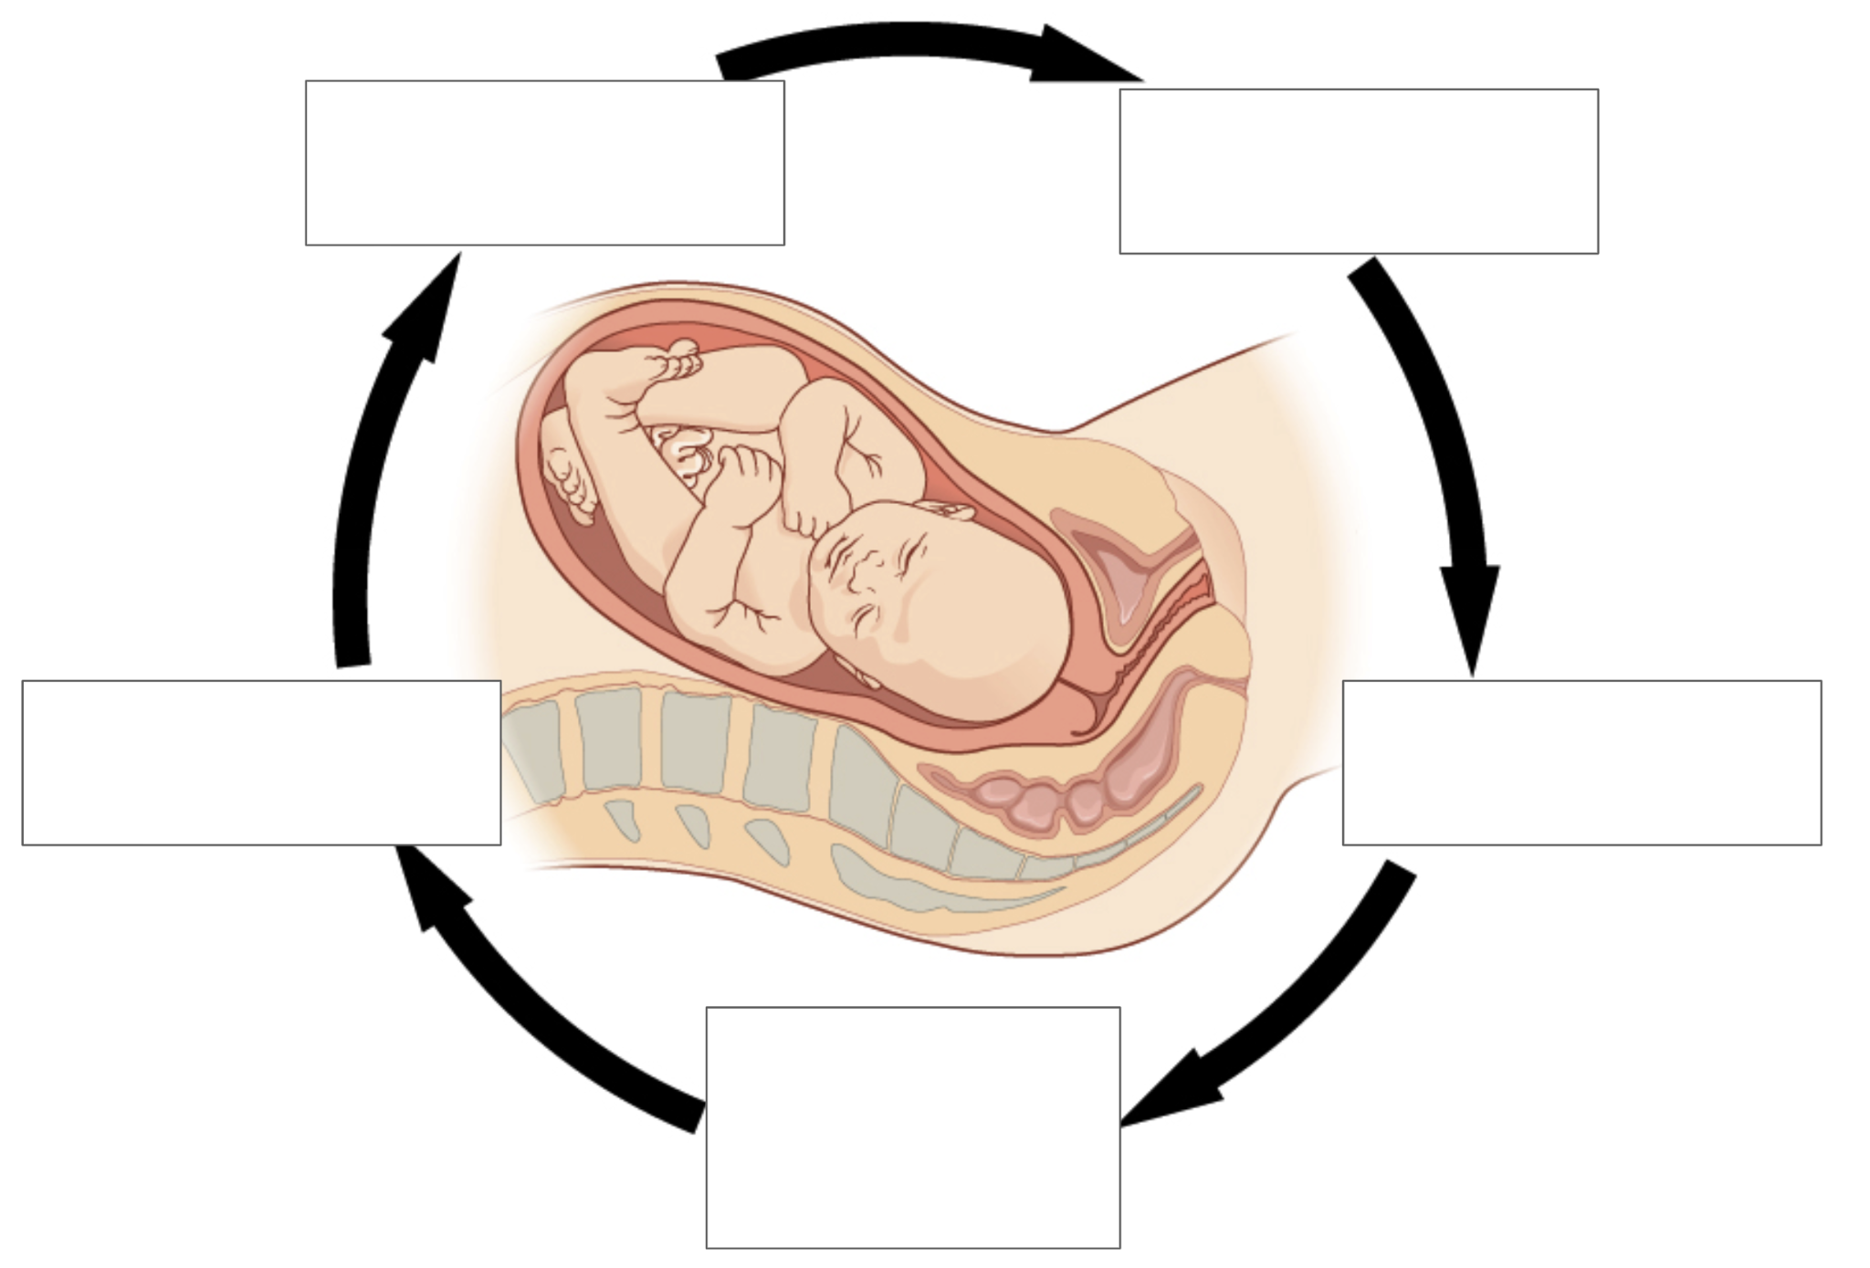

**Steps**

|  |  |  |  |
| --- | --- | --- | --- |
| Brain stimulates the pituitary gland to secrete oxytocin. | Oxytocin stimulates the uterus to contract, moving baby toward cervix. | Nerve impulses from the cervix are transmitted to the brain. | Oxytocin is released into the bloodstream and is carried to the uterus. |
| The baby’s head pushes on the cervix, applying pressure on it. |  |  |  |

Predict when you think this feedback loop stops.

Examine the graph below. The concentration of oxytocin in pregnant women was measured over a period of time. Gestational age refers to the age of the fetus while it is in utero.

​​

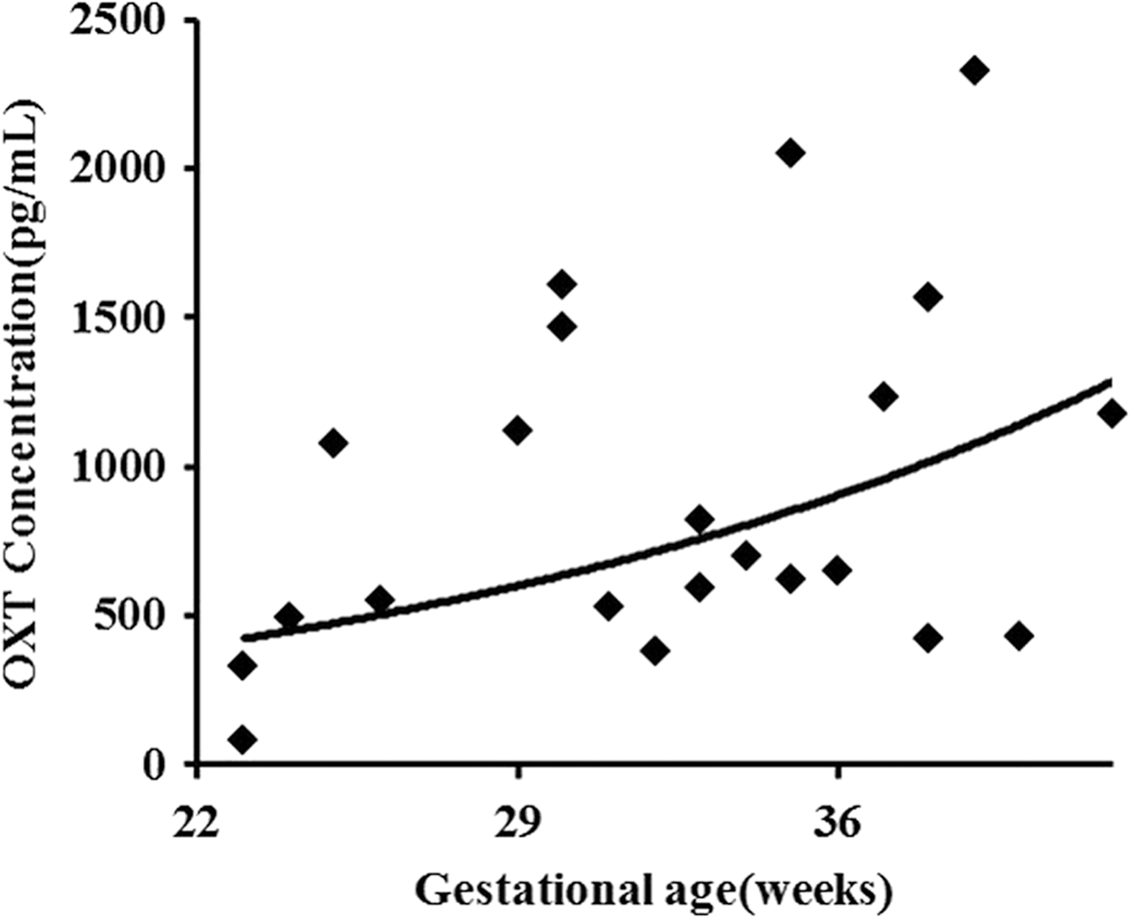

Identify the independent and dependent variables.

Describe the relationship between gestational age and oxytocin concentration.